**32.Design TM to perofrm string comparison**

**W = aba aba**

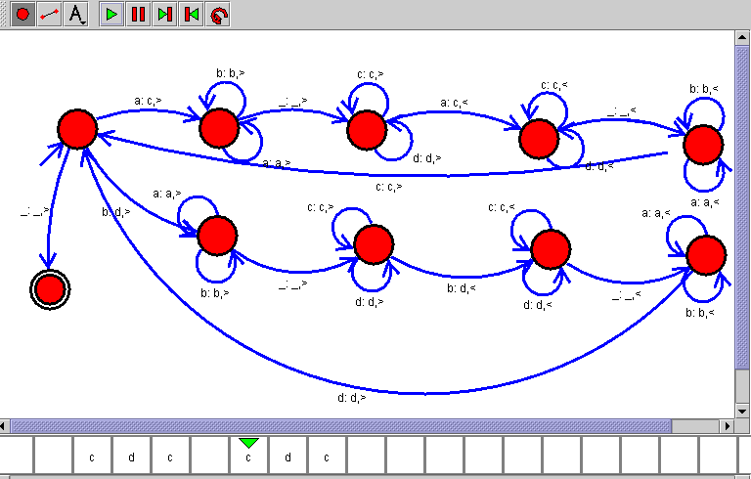

Result:- successfully complete turing machine for to perform string comparison.